REPORT:

1. For variable array size :

* It has been observed for lower cutoff values that System sort is more efficient than the parallel sort implemented which we observed by noting the timestamp.
* Sorting becomes efficient as we increase cut off
* Ideal cutoff can be concluded as little more than 10 % of the array element which generates threads as well as takes less time in sorting
* The observations are in the excel file named ‘assignment5_results’ in the project directory

1. For an array of fixed size - 2000

when we try to use the parallel sort technique, the best cut off value, based on multiple runs and taking an average is - 350

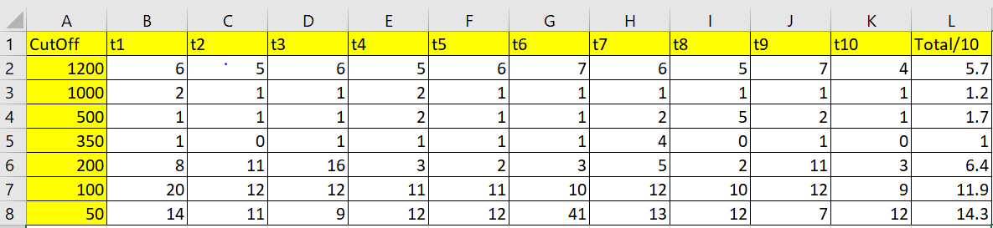

As it can be seen, any cut off value, lower than 350, yields a bad performance, hence making it a bad choice.

Although, the values of 500 and 1000 see good performance results, the minimum cut off value is however 350.